

**AI Multi-Platform Integration Agent**

**Course Number and Title:** MSCS3250-01-F25 and Software Design/ Architecture

**Term and Year:** Fall 2025

**Group Number:** 1

**Team Members:**

* Uma Maheswari Chinnam
* Poorna Chandra Dinesh
* Uday Sai Lakshman Sanam

**Instructor:** Firas Khasawneh

**Project Title:** AI Multi-Platform Integration Agent with LLM-Powered Query Understanding and Multi-Layer Security

Table of Contents

1. Project Introduction 2

1.1 Background and Problem Statement 2

1.2 Project Rationale 2

1.3 Strategic Value 3

2.Project Scope 3

3. High-Level Business Requirements by User Persona 4

3.1 Persona A: The Knowledge Worker (Operational User) 4

3.2 Persona B: The Business Analyst (Analytical User) 5

3.3 Persona C: The Compliance & System Administrator (Governance) 5

4. Architectural Requirements & Service Level Agreements (SLAs) 6

4.1 Service Level Agreements (SLAs) 6

4.2 Architectural Requirements 7

5. Architectural Methodology and Models 9

5.1 Architectural Methodology: Composable Agentic Workflows 9

5.2 Architectural Models 9

5.3 Architecture Diagram 11

6. Infrastructure Requirements 13

6.1 Infrastructure Diagram: Production AI Agent Deployment 14

6.2 Key Infrastructure Requirements Summary: 16

7. Infrastructure Alternatives and Trade-off Analysis 16

7.1 Core Orchestration Engine 17

7.2 AI Cognitive Layer (LLM Inference) 18

7.3 Vector Database 20

7.4 Secrets Management 21

8. Data Model Requirements 22

8.1 Core operational requirements 22

8.2. External endpoint Tables 22

8.3 User and Access Control Models 23

8.4 Knowledge and Training Tables 23

8.5. Data Relationships: 24

8.6 External Data Sources: 25

9. Data Modeling Methodology 25

9.1 Chosen Methodology: Hybrid Domain - Driven Relational and Vector modelling. 25

9.2 Why this methodology is used in enterprise systems 27

9.3 Reasons for adopting this for our project 28

10.Data Modeling Alternatives 29

10.1 Alternative 1: Traditional Relational Model (ERD/3NF) 29

10.2 Alternative 2: Pure Vector Database (No Relational Storage) 31

11. Application Architecture: 33

11.1 The chosen Architecture: 33

11.2 Application Architecture Alternative 2: Decentralized Choreography (Event-First, No Central Orchestrator) 38

11.3 Trade-off comparison 40

12. Security Mechanisms: 42

12.1 Layer -Rate Limiting and IP Blacklist Check 42

12.2 Layer 2- Input Sanitization: 43

13. Availability Techniques: 44

13.1 Multi-Region Active-Active Deployment 44

13.2 Automated Health Monitoring 45

14. Performance Techniques: 46

14.1 Performance Technique 1: Multi-Level Caching Architecture 47

14.2 Performance Technique 2: Asynchronous and Parallel Request Execution 48

15. Component Orchestration and Communication Flow 50

16. CI/CD Pipeline and Deployment Strategy 52

16.1 CI/CD Workflow Diagram 53

16.2 Detailed CI/CD Pipeline Stages 53

16.3 Autoscaling Details 57

17. Project summary: 58

19. Team Contributions: 60

20. Appendix- Sample SQLtables: 61

8.1: Core Operational Requirements 62

8.2 External end points 65

8.3 User & Access Control Models 65

8.4 Knowledge and training tables: 66

20. References: 67

# **1. Project Introduction**

## **1.1 Background and Problem Statement**

In modern enterprise environments, critical business intelligence is often fragmented across disparate "data silos." Organizations typically manage unstructured documents in collaboration suites (e.g., SharePoint, Google Drive) while maintaining structured operational data in relational databases (e.g., PostgreSQL).

This fragmentation creates significant friction for employees, who must constantly "context switch" between multiple applications to retrieve information. Traditional search tools are limited to keyword matching and lack the cognitive ability to synthesize answers from different sources. For example, a simple query like "Compare the Q3 sales figures in the database with the Q3 marketing strategy in Google Drive" requires a human to manually retrieve, read, and correlate data from two separate systems. This manual process is time-consuming, error-prone, and creates a bottleneck in decision-making.

## **1.2 Project Rationale**

We are developing the **AI Multi-Platform Integration Agent** to bridge the gap between static data repositories and dynamic user needs. The industry is shifting from passive "search engines" to active **Autonomous Agents** capable of reasoning and action.

**We are undertaking this project to:**

* **Eliminate Data Silos:** Create a unified, conversational interface (Single Pane of Glass) where users can access data from SharePoint, Drive, and SQL databases without needing to know where that data resides.
* **Enable Complex Reasoning:** Unlike standard APIs that simply fetch data, this agent uses a **Reasoning Layer** (LLM) to interpret the user's "intent." It can autonomously determine which "tools" to use (e.g., "Search Drive" vs. "Query Database") and aggregate the results into a coherent narrative.
* **Enhance Productivity:** By automating the retrieval and synthesis of information, the system significantly reduces the time spent on manual data gathering, allowing employees to focus on high-value analysis.
* **Modernize Integration Architecture:** The project moves away from brittle, hard-coded point-to-point integrations in favor of a **Composable Agentic Workflow**. This ensures the system is modular, scalable, and capable of "Self-Correction" if a data source becomes temporarily unavailable.

## **1.3 Strategic Value**

This solution represents a paradigm shift from "Software-as-a-Service" to **"Service-as-an-Agent."** By implementing an architecture grounded in **Retrieval-Augmented Generation (RAG)** and **Tool Calling**, the organization gains a scalable foundation for future AI initiatives, transforming static data into actionable intelligence.

# **2.Project Scope**

The project focuses on developing an **Autonomous AI Agent** built upon an **Event-Driven Workflow Orchestration Engine**. This system serves as a centralized intelligence layer that integrates disparate enterprise data sources—specifically SharePoint, Relational Databases (PostgreSQL), and Google Drive—into a unified conversational interface.

Unlike traditional static software, this agent employs a **Retrieval-Augmented Generation (RAG)** architecture. It does not merely retrieve data; it interprets user intent, autonomously selects the appropriate integration "Tools" (APIs/Connectors), and synthesizes information from multiple formats (unstructured documents vs. structured SQL rows) to generate context-aware responses.

**The Scope Includes:**

* **Agentic Workflow Design:** Implementation of logic flows for "Intent Classification" (determining what the user wants) and "Tool Routing" (deciding where to get it).
* **Vector Search Integration:** Indexing unstructured documents (from SharePoint/Drive) into a **Vector Database** to enable semantic retrieval based on meaning rather than just keywords.
* **Structured Data Querying:** Developing a "Text-to-SQL" capabilities agent capability to safely query relational databases.
* **Human-in-the-Loop Protocols:** Designing workflows that can pause execution to request human approval for high-stakes or ambiguous actions.

**The Scope Excludes:**

* **Real-Time Bi-Directional Sync:** The agent focuses on retrieval and processing data on-demand, not keeping external databases in constant real-time sync.
* **Creation of Source Systems:** The project assumes SharePoint, Google Drive, and PostgreSQL instances already exist and are accessible via API.

# **3. High-Level Business Requirements by User Persona**

To ensure the **AI Multi-Platform Integration Agent** delivers value across the organization, the requirements are segmented into three core personas: the **Knowledge Worker** (General User), the **Business Analyst** (Power User), and the **Compliance Administrator** (Governance).

## **3.1 Persona A: The Knowledge Worker (Operational User)**

* **Goal:** Rapidly retrieve specific documents or information without navigating multiple complex systems (SharePoint, Drive).
* **Interaction Style:** Natural language questions via chat interface (e.g., "What is the travel reimbursement policy?").

**Requirements:**

* **Semantic Document Retrieval (RAG):** The system must use **Vector Search** to understand the meaning of a query rather than just matching keywords. It must retrieve relevant context from unstructured repositories (SharePoint, Google Drive) even if the user uses different terminology than the source document.
* **Source Attribution:** To build trust, every AI-generated answer must include direct links or citations to the source files (e.g., "Source: Employee_Handbook.pdf in SharePoint").
* **Contextual Awareness:** The agent must maintain "Conversation Memory," allowing the user to ask follow-up questions (e.g., "Does this apply to international travel?") Without restating the original context.

## **3.2 Persona B: The Business Analyst (Analytical User)**

* **Goal:** Synthesize data to derive insights, often combining structured metrics with unstructured narratives.
* **Interaction Style:** Complex, multi-part queries requiring reasoning (e.g., "Pull Q3 sales data from the database and compare it against the Q3 marketing goals in the project folder").

**Requirements:**

* **Multi-Modal Data Synthesis:** The agent must possess the **Reasoning Capability** to query structured SQL databases (for sales figures) and unstructured document stores (for strategy docs) simultaneously, then aggregate these distinct data types into a single analytical summary.
* **Text-to-SQL Generation:** The system must implement a secure **SQL Tool** that translates natural language requests into valid SQL queries to fetch precise metrics from the relational database (PostgreSQL).
* **Structured Output Formatting:** The agent must be able to format responses such as tables, bulleted lists, or downloadable reports (CSV/JSON) suitable for further analysis.

## **3.3 Persona C: The Compliance & System Administrator (Governance)**

* **Goal:** Ensure the agent acts securely, accurately, and within policy boundaries.
* **Interaction Style:** Dashboard monitoring, log review, and configuration management.

**Requirements:**

* **Role-Based Access Control (RBAC) Inheritance:** The agent must respect the permissions of the underlying platforms. It must **not** retrieve or display data (e.g., HR salaries from SQL or Confidential Docs from Drive) if the requesting user does not have explicit access rights to those sources.
* **Full Observability & Audit Trails:** The system must log the entire **"Chain of Thought"** for every interaction. Admins must be able to see exactly which "Tools" were called, what data was retrieved, and the raw prompt sent to the LLM to audit hallucinations or data leakage.
* **Hallucination Guardrails:** The system must implement a "Confidence Score" threshold. If the AI cannot find data with high certainty, it must return a fallback message ("I cannot find this information") rather than invent an answer.

# **4. Architectural Requirements & Service Level Agreements (SLAs)**

## **4.1 Service Level Agreements (SLAs)**

These metrics define the expected performance and reliability boundaries of the AI Agent. Unlike standard database queries which are millisecond-fast, AI reasoning chains require seconds to execute.

**A. Performance & Latency**

* **Simple Retrieval (Informational):**
  + Definition: Queries requiring only a single Vector Search (e.g., "What is the travel policy?").
  + Target: **< 3.5 seconds** (95th percentile).
* **Complex Reasoning (Analytical):**
  + Definition: Queries requiring multi-step Tool Calling, SQL generation, or cross-platform synthesis (e.g., "Summarize the SharePoint contract and compare it to the SQL budget").
  + Target: **< 15.0 seconds** (allows for LLM "thinking" time and sequential API calls).
  + Constraint: User UI must display a "Thinking..." or "Processing Steps" indicator for any request exceeding 2 seconds.

**B. Availability & Reliability**

* **System Uptime:** **99.9%** (allowing ~43 minutes of downtime per month for maintenance).
  + Note: High availability is achieved by deploying n8n in "Queue Mode" with multiple Worker Nodes.
* **Tool Success Rate:** **98%**.
  + Fallback: If a specific tool (e.g., SharePoint API) fails, the system must degrade gracefully (e.g., "I can access the Database, but SharePoint is currently unresponsive") rather than crashing.

**C. Throughput & Scalability**

* **Concurrent Users:** Support for **50 concurrent active sessions** initially.
* **Token Throughput:** The system architecture must handle bursts of up to **10,000 input tokens per minute** (TPM) without throttling, managed via API quota balancing.
* **Scaling Trigger:** Auto-scaling of Worker Nodes triggers when CPU usage exceeds **70%** for 5 minutes.

**D. Data Freshness (Vector Store)**

* **Indexing Latency:** New documents uploaded to SharePoint/Drive must be searchable within **15 minutes**.
  + Mechanism: Scheduled incremental ingestion workflows (running every 10-15 mins) rather than real-time event listeners, to optimize API costs.

**E. Accuracy (AI Specific)**

* **Hallucination Rate:** **< 2%** on verifiable facts.
  + Control: Enforced by setting the LLM temperature to 0.0 for data retrieval tasks and using strict "Grounding" system prompts (answering only from retrieved context).

## **4.2 Architectural Requirements**

**A. Modularity (Composable Workflows)**

* **Requirement:** The architecture must strictly follow a **Composable Workflow Pattern**.
* **Implementation:** Instead of one massive workflow, the system must be broken into:
  + **Router Agent:** The "Brain" that classifies intent.
  + **Sub-Workflow Skills:** Distinct, reusable workflows for specific tasks (e.g., sub-flow-search-sharepoint, sub-flow-query-postgres).
* **Benefit:** Allows individual skills to be updated, debugged, or replaced without bringing down the entire agent.

**B. Security & Governance**

* **Credential Isolation:** API Keys (OpenAI, SharePoint, DB) must be stored in the orchestration engine's secure **Credential Vault** and never hard-coded in workflow nodes.
* **RBAC Propagation:** The agent acts on behalf of the user. When querying SharePoint, it must pass the **User ID** to ensure it only retrieves documents that specific user is authorized to view (User-Delegated Auth).
* **Data Ephemerality:** Sensitive data retrieved from documents must exist only in the execution memory (RAM) during processing and must be cleared immediately after the response is generated.

**C. Interoperability & Standardization**

* **Canonical Data Format:** All tools (SQL, API, Drive) must normalize their output into a standard **JSON Schema** before passing data to the LLM reasoning node. This ensures the AI processes data consistently regardless of the source.

**D. Observability & Tracing**

* **Execution Logging:** Every interaction must generate a unique Execution_ID.
* **Traceability:** Administrators must be able to view the full "Chain of Thought" (e.g., User Input → Router Decision → Tool Output → Final Answer) in the monitoring dashboard (e.g., n8n Execution View or Lang Smith) for debugging and audit purposes.

# **5. Architectural Methodology and Models**

## **5.1 Architectural Methodology: Composable Agentic Workflows**

The project abandons traditional monolithic or pure microservices architecture in favor of a **Composable Agentic Workflow Architecture**. This methodology is centered around **Orchestration** rather than hard-coded application logic.

* **Shift from Code to Logic:** Instead of writing custom code to connect services, we define business logic as visual **Directed Acyclic Graphs (DAGs)** in an orchestration engine (n8n).
* **Modular "Skills":** Each capability of the AI is a self-contained sub-workflow (a "Skill"). For example, "Searching SharePoint" is one modular skill, and "Querying SQL" is another. The primary **AI "Router" Agent** autonomously decides which skill to trigger based on the user's intent.
* **Event-Driven & Asynchronous:** The system is fully event-driven. A user's message acts as a "trigger" event, initiating an asynchronous workflow execution that flows through necessary logic gates, tool calls, and reasoning steps before returning a response.

## **5.2 Architectural Models**

**A. The Orchestration Model (The "Brain")** At the core is the **Workflow Orchestration Engine**. It manages state, handles errors, and executes the decision path defined by the AI.

* **Main Workflow (Router):** Receives the user query, uses an LLM node to classify intent (e.g., Does the user want to search a doc or query a DB?), and routes execution to the correct sub-workflow.
* **Sub-Workflows (Tools):** Encapsulated logic for interacting with specific external systems.
  + Tool_SharePoint_Search: Handles API auth, performs vector search, and returns chunks of text.
  + Tool_PostgreSQL_Query: Receives a natural language request, uses an LLM to generate safe SQL, executes it, and returns structured rows.

**B. The Cognitive Model (RAG & Reasoning)** This model defines how the system thinks and processes information.

* **Reasoning Layer (LLM):** An external Large Language Model (e.g., OpenAI GPT-4o, Anthropic Claude 3.5) acts as the cognitive engine. It is responsible for intent classification, SQL generation, and synthesizing the final natural language response.
* **Retrieval-Augmented Generation (RAG) Layer:**
  + **Ingestion Pipeline:** A scheduled workflow that periodically scrapes documents from SharePoint/Drive, splits them into chunks, generates vector embeddings, and upserts them into the Vector Store.
  + **Semantic Retrieval:** When a user asks a question, their query is converted into a vector, and a "nearest neighbor" search is performed against the Vector Store to find the most relevant context.

**C. The Data Integration Model (The "Limbs")** This model handles secure connections to source systems.

* **Structured Data Connector:** A direct, secure JDBC/ODBC connection to the PostgreSQL database, enabling the execution of read-only SQL queries generated by the AI.
* **Unstructured API Connectors:** OAuth2-authenticated API connections to Microsoft Graph (SharePoint) and Google Workspace API (Drive) for fetching file content and metadata.

## **5.3 Architecture Diagram**

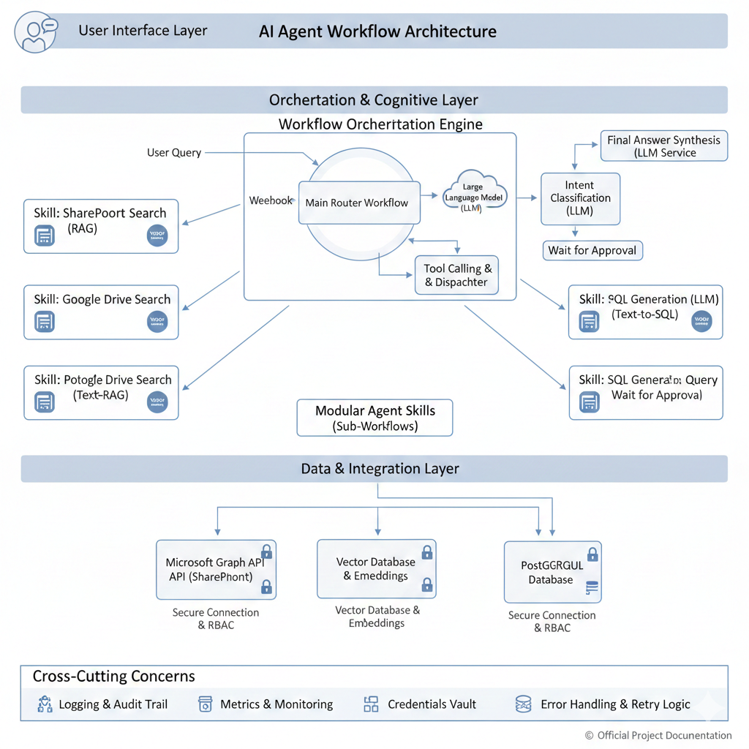

**Diagram Explanation:**

**1. User Interface Layer:**

* Represents any front-end application (e.g., custom web chat, Teams/Slack bot, internal portal) where users interact with the AI Agent. It sends user queries to the Orchestration Layer.

**2. Orchestration & Cognitive Layer:**

* **Workflow Orchestration Engine (n8n implied):** This is the core. It's a robust platform for defining, executing, and managing complex event-driven workflows.
  + **Webhook:** The primary entry point for user queries from the UI Layer.
  + **Main Router Workflow:** The "brain" that orchestrates the entire process.
    - **Intent Classification (LLM):** Uses a Large Language Model to understand the user's intent from their query (e.g., "Do they want to search a document, or query a database?").
    - **Tool Calling & Dispatcher:** Based on the classified intent, this module dynamically selects and triggers the appropriate "Skill" (sub-workflow) for execution.
    - **Wait for Approval:** A built-in Human-in-the-Loop mechanism to pause the workflow for human review on sensitive or ambiguous queries.
    - **Final Answer Synthesis (LLM Service):** After gathering information from various Skills, the LLM processes and synthesizes the retrieved data into a coherent, natural language response to the user.
  + **Modular Agent Skills (Sub-Workflows):** These are independent, reusable workflows, each designed to perform a specific task or interact with a particular data source. They act as "Tools" for the main router.
    - **Skill: SharePoint Search (RAG):** Handles fetching and processing documents from SharePoint using Retrieval-Augmented Generation.
    - **Skill: Google Drive Search (RAG):** Similar to SharePoint, but for Google Drive documents.
    - **Skill: PostgreSQL Search (Text-RAG):** Potentially for metadata or schema descriptions if performing a semantic search on the database itself, or for RAG on database documentation.
    - **Skill: SQL Generation & Query (Text-to-SQL):** Specifically designed to translate natural language into SQL queries, execute them against the database, and return results. Includes a "Wait for Approval" step for critical SQL operations.

**3. Data & Integration Layer:**

* This layer consists of the actual enterprise data sources and the secure connectors that the Agent Skills utilize.
  + **Microsoft Graph API (SharePoint):** Securely accesses SharePoint for document content, metadata, and user permissions.
  + **Vector Database & Embeddings:** Stores vectorized representations (embeddings) of unstructured documents from SharePoint and Google Drive, enabling semantic search (RAG).
  + **PostgreSQL Database:** The relational database storing structured business data, accessed via secure connections.

**4. Cross-Cutting Concerns:**

* These are foundational aspects that apply across all layers of the architecture, ensuring reliability, security, and maintainability.
  + **Logging & Audit Trail:** Comprehensive logging of all agent decisions, tool calls, and LLM interactions for traceability and debugging.
  + **Metrics & Monitoring:** Real-time dashboards to track performance (latency, throughput), errors, and system health.
  + **Credentials Vault:** A secure system for storing all API keys, database credentials, and other sensitive access tokens.
  + **Error Handling & Retry Logic:** Mechanisms built into workflows to gracefully manage API failures, network issues, and LLM timeouts, including retry strategies.

# **6. Infrastructure Requirements**

The infrastructure for the AI Multi-Platform Integration Agent is designed for **high availability, scalability, security, and specialized AI compute**. It follows a **hybrid cloud deployment model**, leveraging cloud services for specialized components while ensuring robust orchestration.

## **6.1 Infrastructure Diagram: Production AI Agent Deployment**

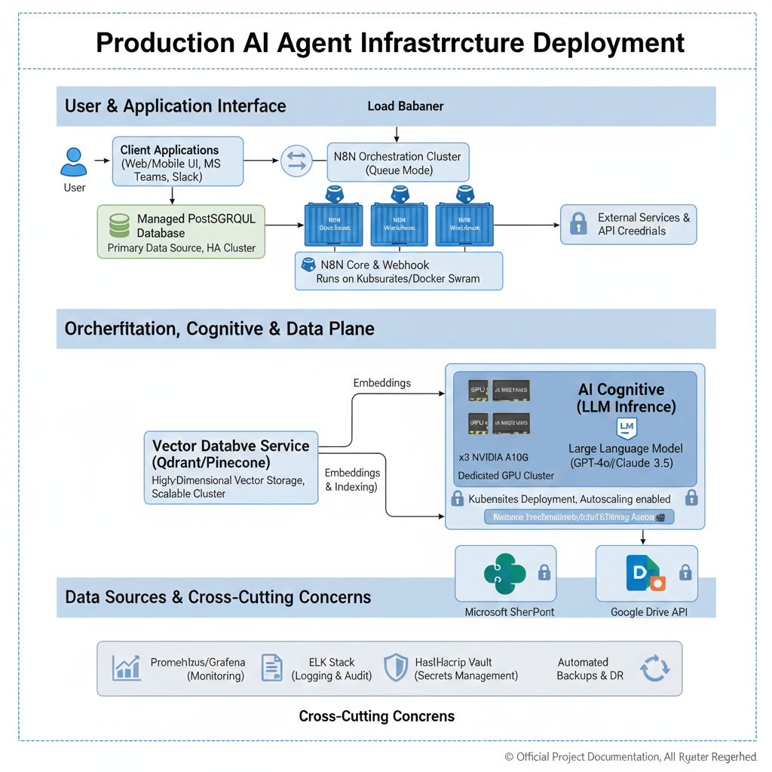

**1. User & Application Interface Layer:**

* **Client Applications:** User-facing interfaces (e.g., custom Web/Mobile UI, Microsoft Teams, Slack bots) that send requests.
* **Load Balancer:** Distributes incoming user requests evenly across the n8n Orchestration Cluster for high availability and performance.

**2. Orchestration, Cognitive, and Data Plane:**

* **n8n Orchestration Cluster (Queue Mode):**
  + **Architecture:** Deployed in Queue Mode (e.g., using Redis or RabbitMQ for queueing) on a Kubernetes cluster or Docker Swarm for resilience and horizontal scalability.
  + **Components:**
    - **n8n Webhook Listener(s):** Ingress points for API calls and user requests.
    - **n8n Main Instance:** Manages workflow definitions and orchestrates execution.
    - **n8n Worker Nodes (xN):** Execute workflow steps in parallel. Auto-scales based on workload.
* **Managed PostgreSQL Database (Primary Data Source, HA Cluster):**
  + The primary relational database (PostgreSQL) where core business data resides. This is a highly available (HA) cluster with automated failover and backups.
* **Vector Database Service (Qdrant/Pinecone):**
  + **Purpose:** Stores high-dimensional vector embeddings of unstructured documents (from SharePoint, Google Drive) for semantic search.
  + **Architecture:** A scalable, dedicated cluster or managed cloud service designed for high-throughput vector similarity search.
* **AI Cognitive (LLM Inference):**
  + **Dedicated GPU Cluster (e.g., 3x NVIDIA A100/A10G):**
    - **Purpose:** Provides the necessary computational power (GPUs) for running Large Language Model (LLM) inference efficiently. This is critical for low-latency responses for complex reasoning tasks.
    - **Deployment:** Runs on Kubernetes with autoscaling enabled (e.g., using KServe, Ray Serve, or directly managed containers) to dynamically adjust GPU resources based on demand.
  + **Large Language Model (LLM):** The selected LLM (e.g., GPT-4o, Claude 3.5, or a fine-tuned open-source model like Llama 3) for intent classification, SQL generation, and final answer synthesis.

**3. Data Sources & Cross-Cutting Concerns:**

* **Microsoft SharePoint / Google Drive API:** External cloud services for unstructured document storage. Accessed via their respective APIs.
* **External Services & API Credentials:** Represents other third-party APIs the agent might interact with (e.g., email, CRM). Access is secured.
* **Prometheus/Grafana (Monitoring):** For collecting and visualizing system metrics (CPU, RAM, latency, error rates) across all components.
* **ELK Stack (Logging & Audit):** Centralized logging (Elasticsearch, Logstash, Kibana) for all workflow executions, LLM interactions, and system events, crucial for debugging and auditing.
* **HashiCorp Vault (Secrets Management):** Securely stores and manages all API keys, database credentials, and other sensitive configurations, providing dynamic access.
* **Automated Backups & DR (Disaster Recovery):** Robust strategies for backing up all critical data (database, vector store, n8n configurations) and ensuring business continuity.

## **6.2 Key Infrastructure Requirements Summary:**

* **Compute:** Dedicated GPU resources for LLM inference; high-CPU/RAM nodes for n8n orchestration.
* **Scalability:** Containerized (Kubernetes/Docker Swarm) deployment with horizontal autoscaling for n8n workers and GPU inference nodes.
* **Resilience:** High-Availability (HA) configurations for n8n, PostgreSQL, and Vector DB; automated failover.
* **Security:** Network segmentation, robust secrets management (Vault), RBAC enforcement at every layer.
* **Observability:** Centralized logging, comprehensive monitoring, and alerting.
* **Data Tiering:** Separation of structured data (PostgreSQL), unstructured data (SharePoint/Drive), and vectorized embeddings (Qdrant/Pinecone).

# **7. Infrastructure Alternatives and Trade-off Analysis**

This section evaluates key infrastructure components against critical **Quality Attributes** to justify the proposed deployment model. The primary goal is to achieve an optimal balance between **Availability, Performance, Scalability, and Cost-Efficiency** for the AI Agent.

## **7.1 Core Orchestration Engine**

| **Quality Attribute** | **Option 1: Single-Instance (Docker)** | **Option 2: Cluster (Kubernetes/Docker Swarm with Queue) - Selected** | **Trade-off Justification** |
| --- | --- | --- | --- |
| **Availability** | Low (Single Point of Failure). Downtime for updates/crashes. | **High (99.9%+)**. Multiple worker nodes, automated failover. | Essential for 24/7 agent operation. **Prevents service disruption.** |
| **Performance** | Limited by single CPU/RAM. Bottleneck for concurrent users. | **High**. Distributed workload, dedicated workers, queueing. | Directly addresses **SLA for concurrent users and throughput.** |
| **Scalability** | Manual, vertical scaling only. | **Excellent**. Horizontal autoscaling of workers based on load. | Critical for accommodating fluctuating user demand and batch processing for RAG ingestion. |
| **Cost** | Low initial cost. | Higher setup complexity, but potentially **lower operational cost at scale** due to efficient resource utilization. | Initial higher complexity is justified by **superior operational resilience and cost-effectiveness for future growth.** |
| **Maintainability** | Simple updates. | Complex initial setup (Kubernetes), but easier rolling updates. | Managed services or Kubernetes streamlines lifecycle management in the long term. |

## **7.2 AI Cognitive Layer (LLM Inference)**

| **Quality Attribute** | **Option 1: External LLM API (e.g., OpenAI, Anthropic) - Selected for primary inference** | **Option 2: Self-Hosted LLM (e.g., Llama 3 on dedicated GPU cluster) - Selected for specific cases/future** | **Trade-off Justification** |
| --- | --- | --- | --- |
| **Availability** | **Very High**. Managed by cloud provider, often with global redundancy. | High, but depends on our infrastructure and SRE team. | Leverages provider's expertise; **minimizes operational burden.** |
| **Performance** | Excellent (fast inference, optimized hardware). Latency depends on network. | **Potentially superior for highly specific, low-latency needs** (local GPU). | External APIs provide **balanced performance with no infra overhead**. Self-hosted for strict latency/data sovereignty. |
| **Scalability** | **Infinite**. Automatically scales with demand, managed by provider. | Excellent, but requires robust Kubernetes/GPU management. | Outsourcing scalability to a provider **reduces CAPEX and operational complexity.** |
| **Cost** | **Variable (per token/call)**. High volume can become expensive. | High upfront CAPEX (GPU hardware), lower variable cost. | **Flexibility and immediate access** outweigh per-token cost for initial phases. Self-hosting considered for massive scale/cost optimization. |
| **Data Sovereignty** | Data processed by third-party. | **Full control** over data residency. | External APIs chosen for **performance/ease of use**, with strict data handling policies. Self-hosting considered for stringent compliance. |

## **7.3 Vector Database**

| **Quality Attribute** | **Option 1: Self-Hosted (e.g., PGVector on Managed DB)** | **Option 2: Dedicated Vector Database Service (e.g., Qdrant, Pinecone) - Selected** | **Trade-off Justification** |
| --- | --- | --- | --- |
| **Availability** | Dependent on DB cluster config. | **Very High**. Built for resilience, often multi-AZ. | Ensures **consistent RAG capability**, critical for agent reliability. |
| **Performance (Search Latency)** | Good for small datasets. Performance degrades for large-scale, high-dimensional vectors. | **Excellent (<50ms for 99% of queries)**. Optimized for vector similarity search. | Directly impacts **RAG performance and agent response time SLAs.** |
| **Scalability** | Horizontal scaling challenging for vector extensions. | **Excellent**. Designed for elastic scaling of vector indexes. | Accommodates massive growth in document volume for RAG. |
| **Cost** | Potentially lower for small scale, but higher operational cost for tuning. | Higher cost, but includes managed services, auto-scaling, and performance guarantees. | **Performance and operational simplicity** justify the higher cost for critical semantic search. |

## **7.4 Secrets Management**

| **Quality Attribute** | **Option 1: Environment Variables / Config Files** | **Option 2: Dedicated Secrets Manager (e.g., HashiCorp Vault, AWS Secrets Manager) - Selected** | **Trade-off Justification** |
| --- | --- | --- | --- |
| **Security** | Low. Prone to leakage, no rotation. | **High**. Centralized, encrypted storage, dynamic secrets, auditing. | Non-negotiable for **data protection and compliance** in an enterprise AI agent. |
| **Compliance** | Difficult to meet standards. | **Excellent**. Auditable access logs, strong encryption. | Fulfills **stringent security and audit requirements.** |
| **Maintainability** | Manual updates, inconsistent across environments. | Automated rotation, centralized management. | **Reduces operational overhead** and human error. |

# **8. Data Model Requirements**

## **8.1 Core operational requirements**

These tables document the daily operations and performance tracking of the system. They concentrate on logging, caching, security, and usage monitoring to guarantee system reliability, traceability, and safety.

**Query logs:** The system records every user's query along with metadata (time stamps) required for traceability, debugging, analytics, and performance monitoring.

**Key Columns:** id, user_id, query_text, sanitized_query, detected_platforms, execution_time_ms, status, error_message, created_at, ip_address, user_agent.

**Endpoint Response Cache:** Caching the frequently used endpoints to reduce redundant Api calls and improve the cache time since its faster to retrieve data from cache rather than the database.

**Key Columns:** id, cache_key, endpoint_name, query_hash, response_data, confidence_score, created_at, expires_at, hit_count, last_accessed

**Security Events:** The system logs all suspicious activity or blocked requests to support threat analysis and security monitoring.

**Key Columns:** id, event_type, severity, client_ip, user_id, request_path, query_attempted, blocked, details, created_at

**Rate Limit Tracking:** The system tracks the number of request rates per second to identify potential misuses and to protect against DDoS attacks.

**Key Columns:** id, client_ip, request_count, window_start, window_end, blacklisted, blacklist_reason, blacklist_until, created_at, updated_at

## **8.2. External endpoint Tables**

**Data sources:** Stores connection info for each endpoint (google drive, database, SharePoint). It allows the orchestrator agent to dynamically access and route to different systems.

**Key Columns**: id, source_type, base_url, auth_type, scopes, credential_reference, created_at.

**Document Metadata Cache:** Caches metadata to enable faster file lookup and reduce API calls to SharePoint or Google Drive.

Key Columns: id, source_type, file_id, file_name, file_path, last_modified, cached_at

## **8.3 User and Access Control Models**

**Users:** Identifies the users that are responsible for queries and permissions.

**Key Columns:** id, username, department, email, created_at

**Roles**: Defines the system roles (admin, analyst, read-only)

**Key Columns:** id, role_name, created_at

**User Roles:** Many-to-many relationships to assign multiple roles to each user

**Key Columns:** user_id, role_id

**Role permissions: Controls** which users can access which agent or endpoint.

**Key Columns:** id, role_id, agent_id, can_access.

## **8.4 Knowledge and Training Tables**

**Prompt templates** – Stores template prompts for consistency and versioning.

**Key Columns:** id, template_name, content, version, created_at

**Training Queries:** Stores manually labelled queries to train the routing model for better routing and retrieval.

**Key Columns:** id, raw_query, labeled_endpoint, created_at

**Feedback:** User feedback for system improvement (reinforcement learning)

**Key Columns:** query_id, rating, comments, created_at.

## **8.5. Data Relationships:**

**Relational Structure (PostgreSQL):**

**Query logs a security events (1: N)**

One query record can produce several associated security events. For instance, a single user request might activate multiple detection rules, including anomaly detection, policy breaches, or classification indicators. Keeping these in a one-to-many relationship enables comprehensive auditing and tracking

**users → query logs (1: N)**

Each user may generate many queries over time. This structure enables session tracking, usage analysis, rate limiting, and access reviews. Storing user–query associations is fundamental for accountability and user-based analytics

**Vector Database Relationships (Vector Repository)**

**File/Document Embeddings**

Every internal or external document is transformed into an embedding and saved as a vector. The vector store holds metadata including document ID, source type, and timestamp. These vectors enable semantic searching instead of relying on keyword matching.

**Query embeddings**

User requests are transformed into embeddings during query time. These embeddings are evaluated against saved document vectors through cosine similarity. This allows for the recovery of pertinent files even if the user's phrasing is different from the content of the files.

**Document–Document similarity (cosine > 0.85)**

Documents exhibiting high semantic similarity (cosine similarity exceeding 0.85) may be considered related. This connection is not kept as a fixed foreign key but is dynamically identified by the vector search engine. These connections facilitate clustering, recommendation, and enhancement of retrieval

## **8.6 External Data Sources:**

The system connects to data sources without storing or copying their original content. Instead, it retains

i. metadata

ii. logs

iii. embeddings

**SharePoint**

The system can access documents and files stored in SharePoint. Only essential metadata or extracted embeddings are stored locally. The original documents remain in SharePoint complying with governance rules.

**PostgreSQL Database**

The system accesses an existing PostgreSQL database to fetch business details such as user profiles, permissions, or transaction records. It does not copy or move this data; it only retrieves the information to fulfill queries.

**Google Drive**

The system can access files and folders stored in Google Drive. Like SharePoint, only metadata or created embeddings are kept locally. This guarantees adherence to storage constraints and prevents redundant data duplication

# **9. Data Modeling Methodology**

## **9.1 Chosen Methodology: Hybrid Domain - Driven Relational and Vector modelling.**

The adopted methodology uses a hybrid structure composed of a-

**1. A relational model:**

A traditional relational database like Postgres is used for all structured, transactional, and operational information. This includes users, security events, roles, limits, metadata, and internal system state.

**2. A vector database:**

A vector database like fiass is used for storing unstructured data and semantic search tasks. This includes Document embeddings, query embeddings, similarity matching, RAG Retrieval.

**3.In-memory Caching Layer:**

Redis acts as a high-speed, in-memory cache that is used to improve response time and reduce load on databases and external systems. This includes frequently accessed query responses, authentication tokens, rate-limit counters, API call responses, and short-lived metadata.

**4.Metadata caches Layer**

To avoid direct copying or duplicating documents from external systems, the system uses a metadata cache stored inside the relational database and Redis for fats retrieval. This includes file names, IDs, paths, and last modified timestamps. It allows speed lookups while maintaining compliance with data governance.

This method follows domain-driven design principles, where every functional domain (such as user management, agent routing, security incidents, query logging, rate limiting) is modeled as a organized and consistent entity. All semantic or content-based retrieval tasks are delegated to the vector store, which holds document embeddings, query embeddings and similarity metrics.

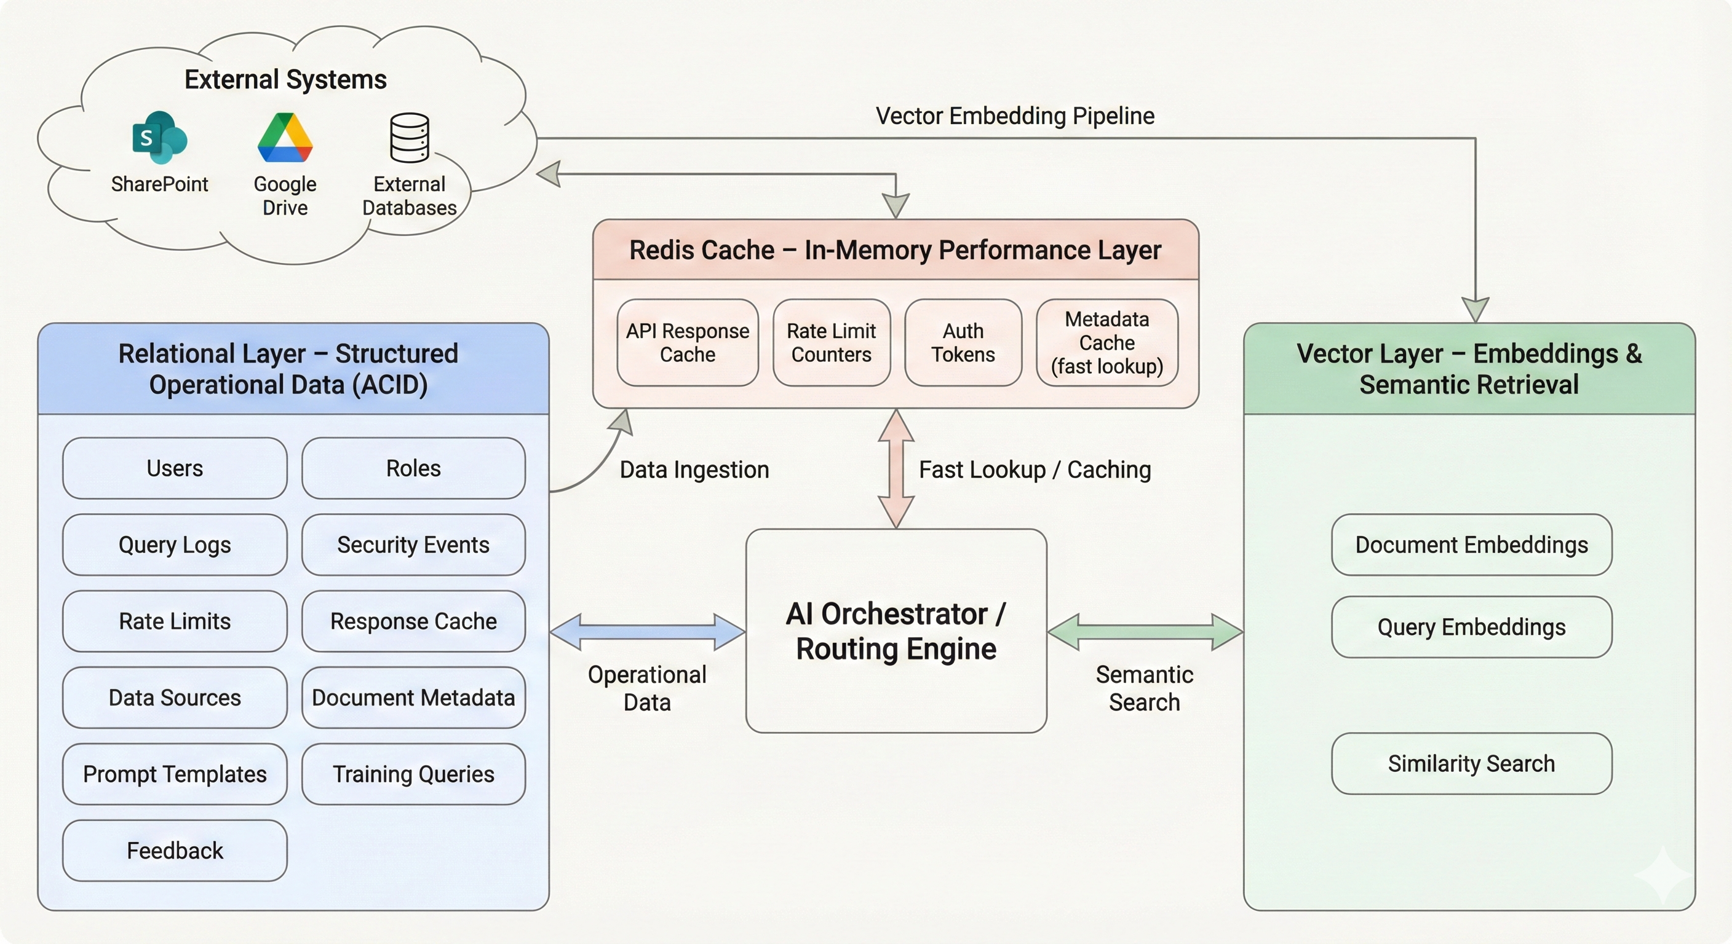

**This integrated method is composed of two stages:**

A relational layer, with behavior that follows ACID principles during operations.

A high-dimensional, probabilistic semantic layer (vector layer) for retrieving documents and queries.

Collectively, they create a reliable, expandable, and understandable framework designed for a high-quality AI agent orchestrator

## **9.2 Why this methodology is used in enterprise systems**

Leading corporations (Microsoft, Airbnb, Uber, Meta, Salesforce) frequently employ Canonical Data Models and Domain-Driven Design (DDD) when creating multi-system API-integrated frameworks because:

* They allow representation of data passing across various systems.
* They distinguish logic from outward data frameworks.
* They enable expansion to endpoints, microservices and data origins.
* They preserve an internal truth model despite variations, in external APIs.
* They perform effectively in event-driven and AI-driven systems where data needs to be normalized prior to the storage of embeddings or logs.

## **9.3 Reasons for adopting this for our project**

**1.Clear separation of Domains**

* Our orchestrator agent has several logical domains such as: User /Authentication Management
* Query logging
* AI Retrieval
* Orchestration (Routing, Api calls)
* External Connectors (The Graph API, Google Drive, Postgres)

**2.Supports distinct data types**

* This system handles:
* Structured operational data (users, logs, roles, rate limits)
* Unstructured documents (SharePoint, Google drive, PDF’s, internal DB extracts)

**3. Delivers high-performance semantic retrieval**

Vector modelling enables Context similarity search, cross-platform document retrieval, RAG workflows.

**4. Minimizes duplication of data systems**:

Only embeddings of documents and metadata are stored in the system but not the full documents. This approach satisfies organizational governance policies and also reduces the storage costs.

# **10.Data Modeling Alternatives**

## **10.1 Alternative 1: Traditional Relational Model (ERD/3NF)**

The original approach involved storing all documents—including their full text—directly in PostgreSQL.  
Documents would reside in a dedicated documents table, with tsvector indexes enabling PostgreSQL’s built-in full-text search for keyword-based querying.

This model emphasizes normalization from 1NF to 3NF.

This model uses entity relationship diagrams and enforces strict relational constraints.  
This model provides a single, centralized data repository and reduces overall infrastructure complexity.

**Benefits**

Using relational database as the only storage engine introduces several operational advantages:

* **Single system to manage** no additional services or clusters required
* **ACID-compliant operations** across all document and metadata workflows
* **Mature and well-supported ecosystem** with extensions, monitoring, and tooling
* **Simplified backup and restoration** using standard PostgreSQL processes
* **Lower operational overhead** compared to maintaining multiple databases

**Constraints**

Despite its convenience, relational databases full-text search presents several limitations for our requirements:

**1. Lack of Semantic Understanding**

PostgreSQL matches only exact keywords and cannot interpret conceptual similarity.  
For example, a search for “financial plan” will not return documents titled “Budget 2025” or “Fiscal Strategy,” even though they are semantically related.

**2. Dependence on Exact Terminology**

Search results rely entirely on literal text matches.  
Documents that describe similar concepts using different vocabulary are frequently missed.

**3. Performance Limitations**

Full-text search performance degrades as dataset size and document length increase.  
Typical query latency ranges between **200–500 MS** for approximately 100,000 documents.

**4. Scalability Challenges**

Full-text (tsvector) indexes continue to grow over time, resulting in slower insert and search operations.

**5. Limited Multilingual Capabilities**

Cross-language retrieval is unreliable; for example, a Spanish query may not match documents written in English, even when equivalent in meaning.

**6. No Support for Vector or Similarity Search**

PostgreSQL does not support embedding-based similarity queries or multi-modal search workflows.

**Reason for Rejection**

The system requires **semantic search**, not strict keyword matching.  
User queries such as:

“Show me the financial planning documents.”

Must surface documents that are conceptually related — including those labeled differently, such as:

* Budget 2025
* Fiscal Strategy
* Q3 Spending Report

PostgreSQL’s keyword-based full-text search cannot meet this requirement. A vector-based system is necessary to deliver semantically relevant results at a scale.

## **10.2 Alternative 2: Pure Vector Database (No Relational Storage)**

This approach proposes using a vector database as the **exclusive storage layer** for all system data—including documents, logs, security events, audit trails, and metadata. Each stored entity is represented as an embedding with optional metadata.

**Architecture**

* All entities stored as vectors
* Metadata attached as key–value pairs
* Query logs embedded and stored as vector entries
* Security and operational events stored as vector records

**Advantages**

Utilizing a single vector database introduces several architectural benefits:

* **Unified Storage Layer** – Removes the need for a relational database
* **High-Performance Similarity Search** – Optimized for embedding-based retrieval
* **Simplified Infrastructure** – One database type to manage
* **AI-Native Design** – Naturally supports semantic search and ML-driven workflows

**Constraints**

Despite its simplicity, this architecture introduces critical operational and compliance gaps:

**1. No ACID Guarantees**

Vector databases typically do not provide fully consistent transactions, making them unsuitable for security logs, audit data, or any information requiring strong data integrity.

**2. Limited Analytical Capabilities**

Vector databases are not optimized for:

* Aggregations
* Complex filtering
* SQL-style analytical queries

This results in slow, impractical, or unsupported reporting operations.

**3. No JOIN Support**

Entity relationships must be manually implemented in the application layer, adding significant development and maintenance overhead.

**4. Compliance and Audit Risks**

Security logs demand:

* High durability
* Strict ordering
* Zero data loss

Vector databases cannot meet these requirements.

**5. High Storage Costs**

Vector databases are priced for vector workloads, making them expensive when used for logs, events, and structured tabular data.

# **11. Application Architecture:**

**The two architectures researched are -**

**1. Orchestrator- Driven Event-driven Microservices (The chosen architecture):** A central workflow engine/orchestrator engine (n8n engine) coordinates domain microservices via events and task queues. This is a proven methodology used at Uber, Netflix, and even Microsoft.

**2. Decentralized Choreography** **(event-first, no central orchestrator):** Services respond to one another's events (pub/sub) and preserve local state; very decoupled but more challenging to monitor and synchronize.

## 11.1 The chosen Architecture:

**Orchestrator- Driven Event-driven Microservices:**

The chosen architecture is an Event-Driven, Orchestrator-Driven Microservices Architecture, with n8n functioning as the main orchestration engine.

In this design, n8n manages and orchestrates the entire workflow pipeline from obtaining the user query to delivering the final summarized response while distributed microservices deal with endpoint-specific functions, data collection, embeddings, and summarization activities.

This architecture offers durability, modularity, visibility, and consistent execution of extended processes. It closely matches the industry standards employed by extensive AI-powered systems (Netflix Conductor, Uber Cadence/Temporal, Azure Durable Functions). n8n is utilized as the orchestrator for managing workflows due to its flexibility, node-based architecture, and appropriateness for multi-step AI agent processes.

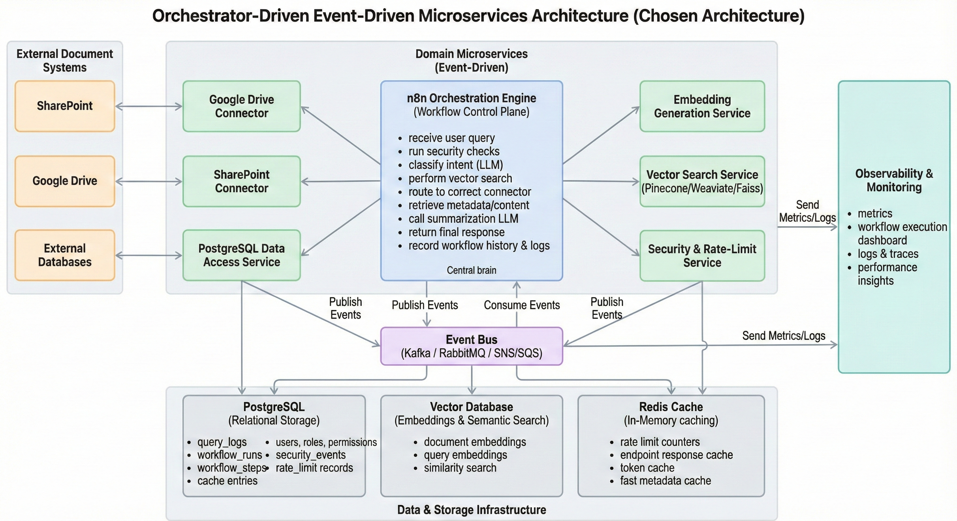

**Architectural structure:**

**a. n8n as the Orchestration Engine (Control Plane):**

n8n serves as the main workflow engine that manages execution across all microservices and connectors. The orchestrator outlines the multi-step process:

* Obtain and confirm a user request
* Invoke security checks (request throttling, data cleansing)
* Request intent categorization from AI Reasoning Layer (LLM).
* Search the vector database for semantic correspondences.
* Dynamically direct the route request to the appropriate endpoint connector.
* Obtain metadata or information from SharePoint, Google Drive, or internal database.
* Send acquired information to the summarization agent (LLM)
* Build and provide the ultimate reply. Record workflow, performance data, and security incidents.
* n8n provides checkpointing, retries, state persistence, and management of long-running tasks, akin to Temporal/Conductor, yet with simpler operational demands tailored to your project's needs.

**b. Microservices and Event-Driven Execution**

Microservices function independently and maintain loose coupling. They interact with one another via the orchestrator or event bus. Typical microservices consist of:

* Google Drive Integration Service
* SharePoint Connector Service
* PostgreSQL Database Access Service
* Embedding Creation Service
* Service for Vector Search (Pinecone/Weaviate/Faiss)
* LLM Summary Service
* Service for Security and Rate Limiting

Every microservice performs a specific task, enabling independent scaling, updates, and monitoring.

Event-driven communication is facilitated by integrations like:

Kafka / RabbitMQ / AWS SNS/SQS

Webhooks

Asynchronous request/response modules in n8n

n8n manages these asynchronous events and guarantees the completion of each step before progressing the workflow.

**c. Data Storage and Supporting Infrastructure**

**Vector Storage Service**

Stores embed representations for documents and metadata collected from all connected endpoints.  
Used to perform semantic similarity searches and to compute confidence scores that guide the routing and retrieval process.

**Relational Storage (PostgreSQL)**

Stores all operational and workflow-related records, including:

* query_logs
* workflow_runs
* workflow_steps
* cache entries
* users, roles, permissions
* security_events
* rate_limit records

The n8n orchestrator interacts with this database to persist in workflow metadata and maintain an auditable history of all executed operations.

**Cache Layer (Redis)**

Used for:

* caching endpoint responses
* reducing repeated external API calls
* achieving sub-second retrieval times
* maintaining rate-limit counters

Provides fast, in-memory access to frequently requested data.

**Observability Layer**

Includes components responsible for monitoring and diagnostics, such as:

* system and performance metrics
* n8n workflow execution dashboard
* step-level workflow tracing
* audit and activity logs

Ensures transparent visibility into system behavior and workflow performance.

**Reasons for Our Selection**

* Reliable processes and automated saving points: orchestration systems provide replay, state preservation and built-in retry mechanisms—crucial for system robustness, during errors and guaranteeing dependable restoration. This is precisely the purpose of Temporal, Conductor, and Durable Functions.
* Unified oversight and auditing functionality: the orchestrator offers a point to track overall progress (essential, for adherence and issue resolution).
* Established error management and recovery: orchestrator workflows enable you to define rollback or compensation actions (, for handling partial connector failures.
* Assistance, for storage: a relational database handling operational data and a vector store managing embeddings can both be conveniently administered.
* Demonstrated at scale: Netflix, Uber, and others utilize orchestration engines in their service ecosystems to manage intricate workflows. Operational considerations.
* Utilize a workflow orchestration system (Temporal/Conductor/Durable Functions) along with a persistent storage solution (Postgres/Cassandra) to guarantee the durability of workflows.
* Utilize an event bus to achieve decoupling and facilitate replay/reprocessing.
* Execute idempotent operations and establish state checkpoints to enable secure retries.
* Observe workflow queues, track latencies, and analyze vector store metrics; provide workflow traces and interface for troubleshooting.

**Advantages**

* High dependability, restart capability, and predictable retries.
* Effective oversight and visibility.
* Simpler to articulate intricate, conditional, multi-stage procedures (e.g., retrieve → embed → evaluate → obtain original → summarize → display).
* Easier to implement global policies (rate limiting, security checks) in a single location.

**Drawbacks**

* Orchestration establishes a control plane that can turn into a bottleneck if it is not expanded horizontally.
* Specific links to workflow definitions (requires monitoring of individuals who alter workflows).
* Somewhat increased operational complexity (workflow persistence storage, considerations for upgrading workflows).

## **11.2 Application Architecture Alternative 2: Decentralized Choreography (Event-First, No Central Orchestrator)**

There is no centralized workflow engine. Each microservice functions autonomously. Reacts to events on the bus. The routing agent produces events (query-submitted). Services. Perform their tasks (classifier, vector lookup, connector services obtain metadata and display results of summarizer processes input and provides the final output). Lengthy operations are controlled exclusively by event messages and local state machines.

**Typical elements**

* Event streaming platforms (Kafka, Pulsar) as the main integration method.
* Independent microservices that handle responsibilities and emit events.
* Embedded pipeline and vector storage.
* Lightweight state stores per service (for local checkpoints).
* A tracing tier that unifies occurrences, for monitoring.

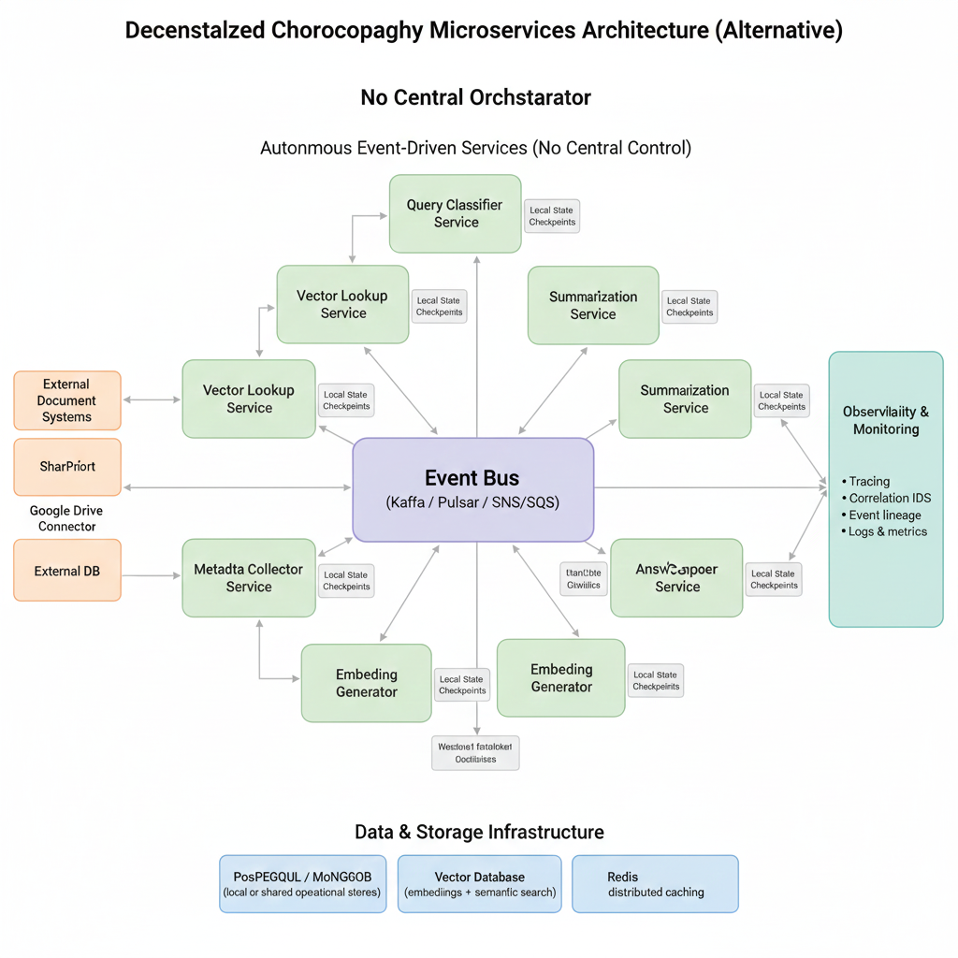

**Reasons why some companies choose choreography**

* Robust decoupling: services evolve independently; minimal centralized supervision.
* Ideal for high throughput and adaptable topologies.
* Perfect, for groups that prioritize autonomy and a variety of coding languages.

**Operational factors**

* Require strict event frameworks and version control.
* For transactions that consist of stages, distributed sagas or compensation strategies need to be employed.
* Observability must be set up (correlation IDs, event lineage) to reconstruct flows.
* Ensuring accuracy throughout the entire process is more challenging because no single entity supervises the sequence and efforts.

**Advantages**

* Extremely independent and adaptable.
* Reduced likelihood of a singular orchestration control plane becoming a bottleneck.
* Groups can develop independently.

**Disadvantages**

* It is more challenging to conceptualize the overall state and to execute intricate conditional processes.
* It is more challenging to ensure consistent recovery and sequential advancement through various stages.
* Eventual consistency may create challenges for accuracy in areas, like rate limiting, security protocols, and audit logging.
* Maintaining observability and tracing at scale is more intricate and costly.

## **11.3 Trade-off comparison**

**Reliability and Restartability**

Orchestrator: robust (integrated retries, checkpointing).

Choreography: Reliable; Requires tailored retry/compensation strategies and service-dependent state.

**Observability and troubleshooting**

Orchestrator: simplified (unified workflow perspective).

Choreography: complex (requires synchronizing activities, among multiple services).

**Coupling and team independence**

Orchestrator: increased centralization of process logic management.

Choreography: increased independence for services.

**Complexity of conditional processes**

Orchestrator: easier to articulate and modify intricate conditional processes.

Choreography: demands organization of events and stories—prone to mistakes.

**Scalability and Throughput**

Both can scale; choreography might be simpler to scale while orchestration engines (Temporal/Conductor) are designed for high throughput when correctly partitioned.

**Operational load:**

Orchestrator: responsible for managing workflow persistence and the engine; facilitates debugging.

Choreography: reduced central infrastructure, but increased complexity for tracking, schema changes, and consistency.

# **12. Security Mechanisms:**

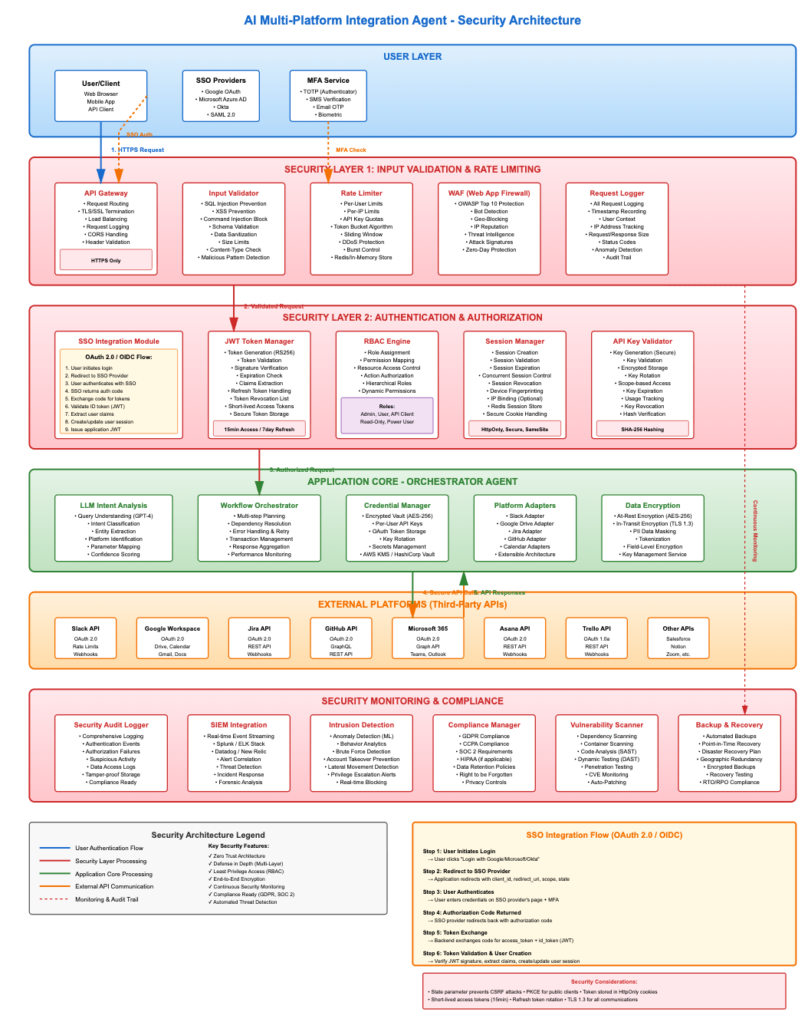

## **12.1 Layer -Rate Limiting and IP Blacklist Check**

**Objective:** Protect the system from abuse, excessive requests, and potential denial of service threats.

Layer 1 emphasizes safeguarding the system against harmful traffic behaviors, rampant request production, and attempts at denial-of-service. This layer screens requests at the initial stage to guarantee the application stays stable and that resources are not overloaded by harmful or accidental high-volume traffic.

**Mechanism:**

* **Rate Limiting:** The system tracks the number of requests sent by every client identified by their IP address or authenticated user ID. A designated threshold (for example 100 requests, per minute) defines the allowed rate.

For example, if a client has made 45 requests, out of the 100 allowed within the given period, the request is allowed to proceed.

When the limit is surpassed, the following requests are either denied or postponed.

**IP Blacklist Verification:** The IP address of the client is checked against a blacklist containing IPs that were earlier flagged for actions, repeated violations or confirmed malicious conduct.

Example: When the IP does not appear on the blacklist → the request is approved.

If the IP is detected → request is immediately blocked.

**Decision Outcome**: Requests are forwarded to the next security layer only if they meet both rate limiting and blacklist criteria, ensuring that excessive, abusive, or harmful traffic is filtered out prior to using application resources.

## **12.2 Layer 2- Input Sanitization:**

**Overview:**

Layer 2 protects the application by making sure that every user-provided input is checked, sanitized, and confirmed prior to processing. This safeguards the system against various injection attacks, script execution efforts, unauthorized file access, and improperly formatted data

**Objective:** Prevent injection attacks, malicious scripts, and unauthorized system access.

**Mechanism:**

* **SQL Injection Detection:** Identifies common SQL attack patterns (e.g., DROP TABLE, OR 1=1).
* **Cross-Site Scripting (XSS) Detection:** Detects executable scripts or HTML elements that could affect clients.
* **Path Traversal Detection:** Prevents access to unauthorized files using relative path techniques (e.g., .../.../etc./passwd).
* **Input Length Validation:** Ensures the input falls within permitted limits (e.g., 28 characters → OK).
* **Sanitization:** Cleans input by removing or neutralizing suspicious characters and patterns before processing.

**Outcome:**

* Input passing all checks → **SANITIZED** and safe for further operations.
* Protects database operations, external API calls, and AI processing from malicious input.

**Note:** This layer is essential for research experiments involving API requests and LLM interactions, providing a controlled environment to evaluate attack mitigation and input validation strategies.

# **13. Availability Techniques:**

## **13.1 Multi-Region Active-Active Deployment**

**Objective:** Maintain uninterrupted service availability with no downtime, even amid regional disruptions.

A Multi-Region Active-Active configuration ensures the application stays operational even if an entire region fails. This approach is frequently utilized by companies such as Amazon, Microsoft, Netflix, and Google to maintain continuous global availability.

The application operates in several regions at the same time, with each region actively handling real user traffic. If a region goes offline, traffic is instantly redirected to functioning regions without affecting users

**Method:**

* Launch the application concurrently across various geographic areas (US-East, EU-West, APAC), all processing traffic actively.
* Load balancers allocate traffic among various application instances within each region.
* Databases implement multi-master replication along with conflict resolution, while caches are replicated asynchronously.
* Global DNS with health checks directs users to the closest functional region.

**Safety & Advantages:**

* Ensures round-the-clock accessibility regardless of server, database, or regional failures.
* Delivers geographic redundancy and minimal latency for users worldwide.
* Facilitates continuous updates and emergency recovery.
* Attains over 99.95% uptime with little user disruption during outages.

## **13.2 Automated Health Monitoring**

**Objective:** Identify issues in advance and self-recover to ensure continuous availability.

Automated Health Monitoring acts as an approach to maintain high availability within complex orchestrator systems. The system continuously monitors its condition and identifies problems quickly. Independently fixes issues before they escalate into downtime, removing the necessity for human involvement.

Companies like Netflix, Uber, Meta, and Cloudflare depend on self-monitoring and self-repair systems to ensure almost constant uptime

**Method:**

* Layered health assessments: infrastructure, application, dependencies, and business logic.
* Self-repairing mechanisms involve automatic service restarts, circuit breakers, connection pool handling, memory leak recovery, and cascading failure avoidance.
* Dashboards for real-time monitoring observe uptime, performance indicators, and recovery occurrences.

Notifications and automated reactions guarantee smooth decline during partial failures.

**Safety & Advantages:**

* Lowers mean time to recovery (MTTR) to 1–2 minutes, reducing user impact.
* Guarantees are nonstop functioning around the clock without human involvement.
* Enables limited functionality to sustain service despite dependency breakdowns.
* Attains approximately 99.94% uptime through automated recovery measures.

# **14. Performance Techniques:**

The two techniques that we chose to improve our application performance. They are

## **14.1 Performance Technique 1: Multi-Level Caching Architecture**

The system uses multi-tier caching to reduce repeated calculations and calls to APIs. Multiple cache levels are implemented: in-memory caches (Redis) for requested metadata, caching of vector search outcomes to avoid duplicate similarity calculations, and LLM response caching to prevent unnecessary model executions. This significantly decreases response times since requested data is served directly from fast in-memory storage instead of slower database or external API operations. Such an approach is vital for orchestrators that frequently access data from external sources. It lowers latency, cuts expenses, and enhances total throughput.

**Multi-Level Intelligent Caching Strategy**

**Aim:** Decrease overall query delay or response time by limiting redundant calls to external API’s and vector searches.

Reasons for choosing this technique:

External calls—database queries, vector searches, Graph API, Drive API, LLM requests—are slow.

Caching keeps the calculated or fetched data in quick memory (RAM or edge cache), ensuring that subsequent requests are answered immediately.

**Method:**

Establishes caching across multiple layers:

**LLM Analysis Cache:** It stores output of intent classification or summarization for semantically similar queries. This also helps avoid redundant LLM Calls for near duplicate requests.

**Endpoint Response Cache:** It stores responses from SharePoint, Google Drive and Postgres queries. This also supports time-based expiration and avoids unnecessary calls to external systems.

**Vector Search Cache:** It stores the frequently retrieved results from semantic search. It is useful for high-traffic queries that repeatedly need the system to match the same documents.

**API Response Cache:** It is a short-lived response to a network edge provider to provide quicker access to frequently used data. (metadata)

Cache invalidation methods include time-based expiration, event-driven invalidation, and manual clearing. Semantic caching allows reuse of similar queries through vector embeddings, improving cache hit rates.

**Advantages:**

* Reduces load on external dependencies (endpoints).
* Minimizes LLM API usage, endpoint calls, and database load, yielding cost savings.
* Improves responsiveness by fetching objects directly from in-memory cache.
* Stabilizes the orchestrator’s performance even when the other external systems slow down by utilizing the cachedata.

## **14.2 Performance Technique 2: Asynchronous and Parallel Request Execution**

The application utilizes asynchronous and parallel execution to handle several external tasks at the same time. The orchestrator performs calls to SharePoint, Google Drive, PostgreSQL, vector databases, and LLMs concurrently rather than in sequence by utilizing asynchronous programming models. This guarantees that the overall response time is equal to the length of the slowest call instead of the total of all calls. Enterprise orchestrators utilize this technique as it significantly enhances response speed, facilitates high concurrency, and avoids bottlenecks caused by sluggish external systems

**Asynchronous Processing with Parallel Endpoint Queries**

**Objective:** Minimize overall query response time by executing multiple endpoint requests concurrently rather than sequentially.

AI orchestrators frequently need to call multiple external systems such as Vector DB, PostgreSQL, SharePoint, Google Drive, LLM API’S, and Local pre-processing services. When all these are executed sequentially, latency can be extremely high.

**Reason for choosing this technique:**

Parallel dispatch is a frequent performance strategy used in enterprise orchestrators like Uber’s Fusion Orchestrator, Netflix’s API Gateway, and Amazon Lambda. It enhances responsiveness by minimizing idle time during external IO-bound tasks. The n8n orchestrator inherently supports parallel branches and asynchronous execution, fitting this model effectively.

Impact on Token performance (Improving token performance in AI system):

The effectiveness of tokens within an AI system is influenced by the inherent processing speed of the LLM along with the framework that supplies context, fetches documents and prepares the prompt. When the orchestrator must gather data from sources—such as a vector database, external APIs, internal databases or connector microservices—the delay is often dominated by the slowest dependency.

When the system carries out these tasks sequentially, the LLM has to wait until all earlier processes are complete before it can begin generating output. This delays the moment token generation can begin and significantly affects how responsive the AI system feels.

Also, asynchronous parallel processing enables the orchestrator to dispatch all required endpoint requests. As a result:

* The LLM acquires all context beforehand.
* Token streaming (the production of tokens) begins earlier.
* The system reduces delays when the LLM depends on outside services.
* The user experiences a time from start to first token and overall quicker replies.
* This architectural enhancement guarantees that LLM token production is never hindered by upstream constraints.

**Method:**

* The orchestrator dispatches requests at the time, to SharePoint, Google Drive, PostgreSQL and the vector database allowing all external operations to run in parallel.
* Asynchronous workflow execution enables the orchestrator to continue with the steps without pausing or waiting for each separate call to finish.
* Network operations improve through connection pooling and request multiplexing, reducing setup expenses, for frequent API communications.
* Timeout policies and graceful degradation methods allow the system to operate despite some endpoints becoming slow or non-responsive, improving resilience to faults.
* Due to the earlier collection of necessary contexts, the LLM can start generating tokens sooner, leading to quicker perceived and actual response times for users

**Advantages:**

* Decreases in total delays and waiting periods.
* Increases throughput by utilizing parallel processing rather than sequential execution.
* Prevents external systems from delaying the whole process.
* Facilitates high concurrency without overloading orchestrator resources.
* This method provides reliable performance improvements in multi-system integration situations where separate calls can be performed concurrently

# **15. Component Orchestration and Communication Flow**

The orchestration of components in the **AI Multi-Platform Integration Agent** follows an **event-driven, hub-and-spoke model**. The **Orchestrator (n8n Workflow Engine)** acts as the central hub, managing the state of each request and coordinating communications between the user, the cognitive reasoning layer, and the various specialized "skills."

The following Sequence Diagram illustrates the step-by-step communication flow for a typical user query that requires searching for a document repository.

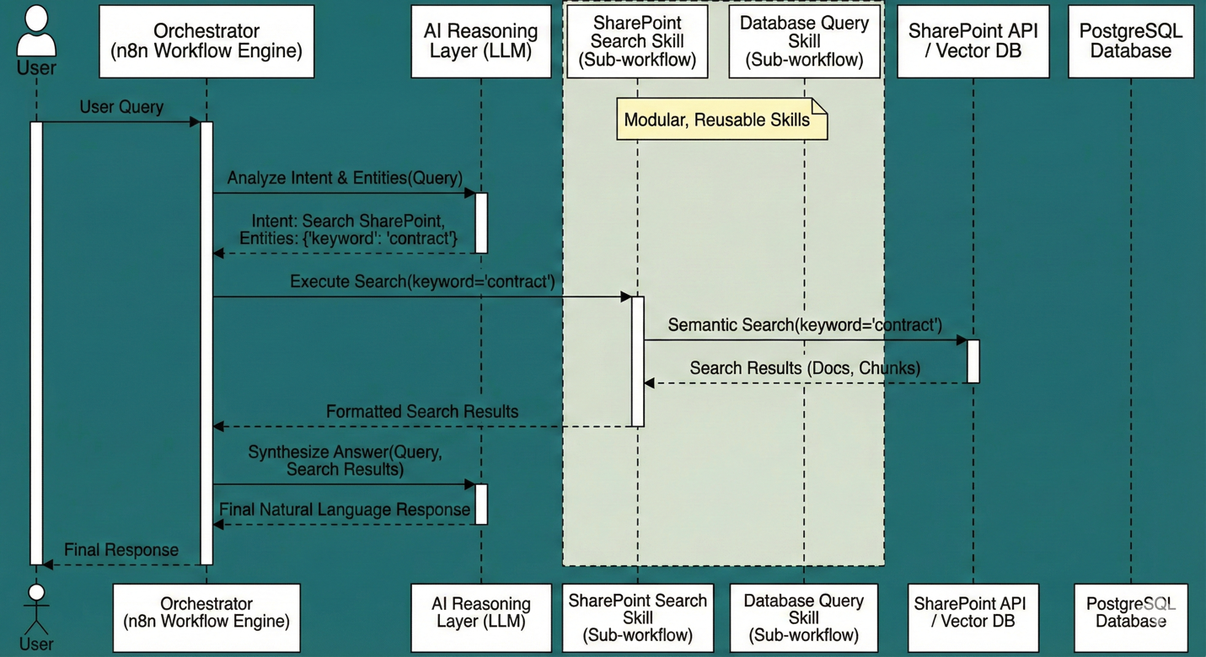

**Diagram Explanation:**

1. **User Query:** The process begins when a **User** submits a natural language query (e.g., "Find the latest contract") to the system via a chat interface.
2. **Intent Classification:** The **Orchestrator** receives the query and first sends it to the **AI Reasoning Layer (LLM)**. The LLM's job is not to answer the question yet, but to classify the user's **intent** and extract relevant **entities** (e.g., Intent: Search SharePoint, Entity: keyword='contract').
3. **Tool Routing (Skill Execution):** Based on the determined intent, the **Orchestrator** dynamically routes the request to the appropriate **Modular Skill**. In this case, it is called the **SharePoint Search Skill (Sub-workflow)**, passing the extracted keyword.
4. **Data Retrieval:** The **SharePoint Search Skill** executes its logic, which involves performing a **Semantic Search** against the **SharePoint API / Vector DB**. The most relevant document chunks are retrieved.
5. **Data Return:** The **SharePoint Search Skill** formats the retrieved results and returns them to the main **Orchestrator**.
6. **Response Synthesis:** The **Orchestrator** now possesses both the original user's query and the retrieved context. It sends this combined information back to the **AI Reasoning Layer (LLM)** with a prompt to synthesize a final, natural language answer based only on the provided context.
7. **Final Response:** The **AI Reasoning Layer** generates the final response, which the **Orchestrator** then delivers back to the **User**.

This orchestration pattern ensures that the AI's reasoning is separated from tool execution, making the system highly modular, easier to debug, and capable of handling complex, multi-step tasks.

# **16. CI/CD Pipeline and Deployment Strategy**

A robust Continuous Integration/Continuous Deployment (CI/CD) pipeline is paramount for the AI Multi-Platform Integration Agent to ensure rapid, reliable, and scalable deployments. Given the workflow-centric nature of the application (n8n on Kubernetes), the CI/CD strategy focuses on automating **workflow versioning, containerization, and orchestrated deployments**.

## **16.1 CI/CD Workflow Diagram**

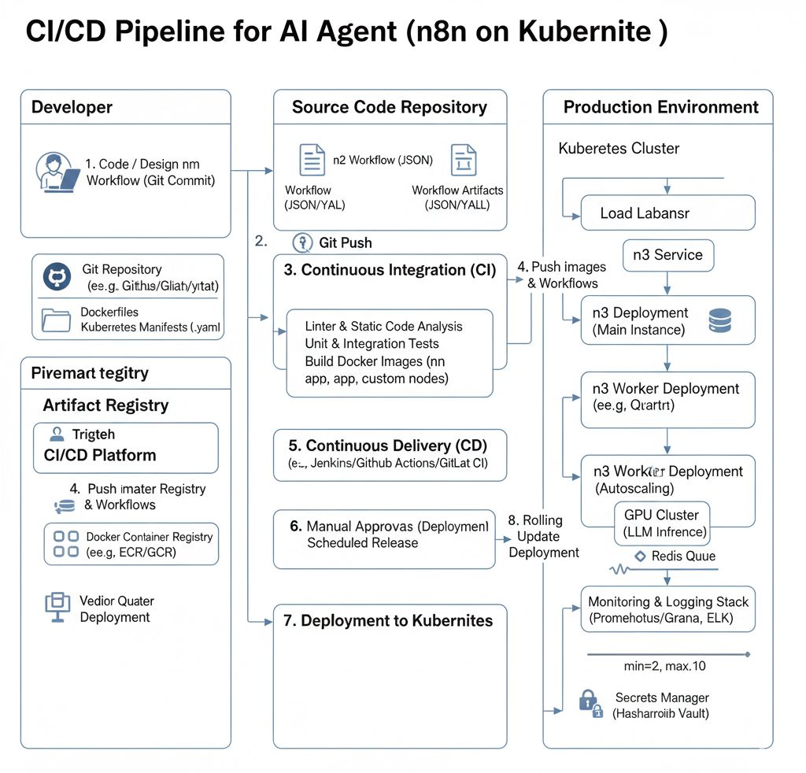

## **16.2 Detailed CI/CD Pipeline Stages**

The CI/CD pipeline is broken down into distinct stages, each with specific tools and objectives:

**1. Developer Workflow & Source Code Management**

* **Process:**
  + **Code & Workflow Design:** Developers design or modify n8n workflows (which are JSON definitions), write custom n8n nodes (if any), and define Kubernetes manifests (.yaml files for deployments, services, autoscaling rules).
  + **Version Control:** All code and workflow definitions are managed in a Git repository (e.g., GitHub, GitLab, Bitbucket). This includes Dockerfiles for n8n and custom nodes, n8n workflow JSONs, and Kubernetes configuration files.
* **Key Tools:**
  + **Git:** For version control.
  + **Integrated Development Environment (IDE):** For writing code and designing workflows.

**2. Git Push (Trigger CI)**

* **Process:** A developer commits changes and pushes them to the central Git repository. This git push event automatically triggers the Continuous Integration (CI) pipeline.
* **Key Tools:**
  + **Git Hooks / Webhooks:** Configured in the Git repository to send notifications to the CI/CD platform (e.g., Jenkins, GitHub Actions, GitLab CI/CD) upon new commits or pull requests.

**3. Continuous Integration (CI)**

* **Objective:** To ensure code quality, functional correctness, and build reproducible artifacts.
* **Process:**
  + **Linter & Static Code Analysis:** Code is analyzed for style, potential bugs, and security vulnerabilities (e.g., SonarQube for custom nodes, jsonlint for n8n workflows).
  + **Unit & Integration Tests:** Automated tests are run for custom n8n nodes and to validate the logic of key n8n workflows (e.g., using n8n's internal testing capabilities or external frameworks to simulate workflow execution).
  + **Build Docker Images:**
    - **n8n App Image:** A Docker image for the n8n main instance and worker nodes (often based on the official n8n image, with project-specific configurations or custom nodes baked in).
    - **Custom Nodes:** Separate Docker images for any custom-developed n8n nodes.
    - **LLM Inference Images:** (If self-hosting an LLM) Docker images containing the LLM model and inference server.
  + **Artifacts:** The successfully built Docker images are tagged with version numbers (e.g., Git commit SHA, build number) and pushed to a Docker Container Registry.
* **Key Tools:**
  + **Jenkins / GitHub Actions / GitLab CI/CD:** Orchestrates the CI steps.
  + **Docker:** For building container images.
  + **Docker Container Registry:** (e.g., Docker Hub, Google Container Registry (GCR), Amazon ECR, Azure Container Registry (ACR)) For storing and versioning Docker images.

**4. Push Images & Workflows to Registry / Deployment Repository**

* **Process:** After a successful CI build, the Docker images are stored in the **Artifact Registry**. n8n workflow definitions (JSON files) and Kubernetes manifests (.yaml) are also typically stored in a versioned artifact repository or directly in the Git repository if managed as "GitOps" manifests.
* **Key Tools:**
  + **Docker Container Registry:** (As above)
  + **Artifact Repository:** (e.g., Nexus, Artifactory) or Git for manifest management.

**5. Continuous Delivery (CD) - Pre-Deployment**

* **Objective:** To prepare for deployment, often involving approval gates or scheduled releases.
* **Process:** The CD pipeline takes the validated artifacts and prepares them for deployment. This stage might include:
  + **Configuration Management:** Applying environment-specific configurations (e.g., API keys, database connection strings) using tools like Helm or Kustomize.
  + **Security Scans:** Further scans on Docker images for known vulnerabilities.
  + **Approval Gates:** For critical environments (e.g., Production), a manual approval step might be required before proceeding to actual deployment.
  + **Scheduled Releases:** Deployments can be scheduled for off-peak hours or specific release windows.
* **Key Tools:**
  + **Jenkins / GitHub Actions / GitLab CI/CD:** Orchestrates the CD steps.
  + **Helm / Kustomize:** For templating and managing Kubernetes configurations.

**6. Deployment to Kubernetes**

* **Objective:** To deploy the application components to the target Kubernetes cluster.
* **Process:**
  + **Kubernetes Manifests Application:** The CI/CD pipeline applies the versioned Kubernetes manifests (.yaml files) to the target cluster. This includes:
    - **n8n Service:** Defines how the n8n application is exposed (e.g., via LoadBalancer).
    - **n8n Main Instance Deployment:** The deployment for the core n8n application.
    - **n8n Worker Deployment:** The deployment for n8n worker nodes, often configured for horizontal autoscaling.
    - **GPU Cluster Deployment (LLM Inference):** Deployment for the dedicated GPU-enabled inference servers, also configured for autoscaling.
    - **Redis Queue Deployment:** (If using Redis for n8n queue mode)
  + **Secrets Integration:** Kubernetes deployments securely fetch sensitive configurations (API keys, database credentials) from a Secrets Manager (e.g., HashiCorp Vault) at deployment time, rather than baking them into images.
  + **Rolling Updates:** Deployments are performed as rolling updates to ensure zero-downtime during application upgrades.
* **Key Tools:**
  + **Kubectl:** Kubernetes command-line tool.
  + **Helm / Argo CD / Flux CD:** For managing complex deployments and enabling GitOps practices.
  + **Secrets Manager:** (e.g., HashiCorp Vault, Kubernetes Secrets with external integration)

## **16.3 Autoscaling Details**

The CI/CD pipeline also plays a critical role in setting up and managing autoscaling to meet user demand, as discussed in the SLA section.

* **Horizontal Pod Autoscaler (HPA):**
  + **n8n Worker Deployment:** HPAs are configured to automatically scale the number of n8n worker pods up or down based on CPU utilization or custom metrics (e.g., queue length of pending n8n jobs).
    - Example: min_replicas=2, max_replicas=10, target_cpu_utilization=70%.
  + **GPU Cluster (LLM Inference):** HPAs or dedicated GPU autoscalers (like Kubernetes' Karpenter or cloud-provider specific autoscalers) scale the number of GPU-enabled inference pods based on GPU utilization, request queue depth, or custom metrics.
    - Example: min_gpu_pods=1, max_gpu_pods=3, target_gpu_utilization=60%.
* **Cluster Autoscaler:**
  + Works in conjunction with HPA. If HPAs try to scale pods but there aren't enough nodes in the Kubernetes cluster, the Cluster Autoscaler adds new nodes (VMs with appropriate CPU/GPU resources) to the cluster.

**16.4 Monitoring & Logging Integration**

* **Objective:** To provide real-time visibility into the health and performance of the deployed application.
* **Process:** The CI/CD pipeline ensures that all deployed components are configured to:
  + **Emit Metrics:** Application components (n8n, LLM servers) expose metrics (e.g., HTTP request count, latency, error rates, queue sizes).
  + **Generate Logs:** All activity, including workflow executions, LLM calls, and system events, is logged.
* **Key Tools:**
  + **Prometheus / Grafana:** For collecting, storing, and visualizing metrics, and defining alerts.
  + **ELK Stack (Elasticsearch, Logstash, Kibana):** For centralized log aggregation, searching, and analysis.

# **17. Project summary:**

After validation, n8n starts a new workflow execution and records the initial state. The LLM-based reasoning layer is then invoked to classify the user’s intent, identify the target endpoint, and extract keywords or entities. The system next consults the vector database to evaluate semantic similarity between the user’s question and existing document embeddings. Based on confidence scores, the orchestrator determines the most suitable data source for SharePoint, Google Drive, or the internal database and routes the request accordingly.

Once the correct endpoint is determined, n8n triggers the corresponding connector microservice, which interacts with external APIs to retrieve document metadata or full content. The orchestrator then forwards the retrieved information to the summarization agent, which generates a focused, context-aware summary designed strictly from the returned data. By enforcing grounded summarization, the system prevents hallucinations and maintains factual accuracy.

After the summarization step, the orchestrator aggregates the contextual information, extracts key insights, and constructs a final structured response. It then returns this output to the user while recording each stage in the operational database, including routing decisions, connector calls, vector search scores, and workflow execution details. This provides complete traceability for auditing, debugging, and long-term system evaluation.

To support scalability and responsiveness, the platform incorporates Redis-based caching, asynchronous tool execution, batched vector lookups, and efficient batching of external API requests. The architecture also integrates layered security mechanisms, such as continuous input sanitization, IP monitoring, anomaly detection, and role-based access controls. Observability is facilitated through n8n’s execution dashboard, system logs, workflow traces, and performance metrics, giving operators full visibility into every step executed by the system.

Overall, this project delivers a comprehensive, secure, and extensible AI orchestration framework capable of integrating multiple external systems, performing intelligent intent-based routing, and generating high-quality summaries using LLMs. The combination of orchestrator-driven workflow management, hybrid data modeling, semantic vector search, and strong operational controls establishes a solid foundation for enterprise-level AI automation and scalable knowledge retrieval.

**18. Personal Experience:**

As a group, we discovered this system design project to be an intellectually enriching experience that enhanced our technical knowledge and teamwork abilities. Even though we did not execute the entire solution, the design process of an AI Orchestrator System necessitated extensive research, meticulous planning, and collaborative effort. Navigating various layers of the architecture—security, data modeling, workflow orchestration, endpoint integration, and performance optimization—allowed us to understand the complexity of contemporary AI systems and the importance of careful planning prior to starting development.

A significant takeaway was a much improved comprehension of workflow orchestration within enterprise systems. Exploring tools like n8n, Netflix Conductor, Temporal, and Azure Durable Functions provided us with practical insights into how actual platforms handle stateful processes, retries, prolonged logic, and multi-step workflows. Modeling these behaviors, even without creating the orchestrator, helped us comprehend why organizations depend significantly on orchestration for reliability and scalability

Another crucial learning result was the development of a combined data modeling approach. By analyzing and comparing alternatives we concluded that neither relational data nor vector embeddings alone would sufficiently meet enterprise requirements. Designing a model that integrates relational storage with semantic vector search enabled us to understand how AI-driven systems handle compliance, traceability and effective retrieval. This process improved our ability to evaluate data compromises and justify choices.

In general, the initiative improved our capacity to create modular, maintainable, and scalable system architectures. Collaborating on diagrams, defining workflows, and creating structured documentation enhanced our communication and technical writing abilities. While this project emphasized design, it offered significant insights into enterprise AI frameworks, architectural thinking, and collaborative problem-solving—capabilities that will be beneficial in upcoming studies and work settings.

# **19. Team Contributions:**

The primary responsibilities of each team member include -

**Uma Maheswari Chinnam:**

Contributed to the planning of the AI Orchestrator System covering workflow management, component communication, and event-driven process logic.

Contributed to the data modeling segment, assisting in specifying both relational and vector storage specifications while ensuring consistency with system functions and retrieval necessities.

Contributed to the creation of performance enhancement methods, such as caching techniques and asynchronous execution strategies.

Helped in drafting critical parts of the written report, guaranteeing technical precision and clear articulation of architectural choices.

Assisted in developing diagrams and visual representations illustrating workflows, communication patterns, and system architecture.

**Poorna Chandra Dinesh**

Contributed to the analysis of infrastructure needs and options, encompassing cloud deployment methods, scaling tactics, and considerations for multi-region availability.

Participated in enhancing availability and reliability methodologies, including automated monitoring, fault tolerance, and failover strategies. Contributed to assessing and contrasting application architecture options, aiding in the decision of the ultimate orchestrator-driven design.

Focused on developing the CI/CD pipeline framework, encompassing building, testing, and deployment phases to facilitate automation and scalability.

Assisted in the creation of documentation by enhancing architectural descriptions and ensuring the technical sections were accurate and thorough.

**Uday Sai Lakshman Sanam**

Assisted in outlining the project parameters, business necessities, and user profiles, ensuring precise alignment with organizational document-retrieval requirements.

Involved in examining system specifications, including endpoint integration aspects, for SharePoint, Google Drive, and PostgreSQL.

Assisted in creating workflow and sequence diagrams that demonstrate how orchestrator-driven communication and modular skill implementation operate.

Focused on security architecture elements like rate-limiting frameworks, request cleaning, and detection of universal attack vectors.

Assisted in creating the appendix materials by arranging SQL schemas, defining table structures, and verifying supporting documents.

# **20. Appendix- Sample SQLtables:**

## **8.1: Core Operational Requirements**

**1. Query Logs:**

CREATE TABLE query_logs (

id UUID PRIMARY KEY DEFAULT gen_random_uuid(),

user_id VARCHAR(255) NOT NULL,

query_text TEXT NOT NULL,

sanitized_query TEXT NOT NULL,

detected_platforms TEXT[], -- Array of platforms queried

execution_time_ms INTEGER,

status VARCHAR(50), -- success, error, partial_success

error_message TEXT,

created_at TIMESTAMP DEFAULT CURRENT_TIMESTAMP,

ip_address INET,

user_agent TEXT

);

CREATE INDEX idx_query_logs_user ON query_logs(user_id);

CREATE INDEX idx_query_logs_created ON query_logs(created_at DESC);

**2: Endpoint Response Cache:**

CREATE TABLE endpoint_cache (

id UUID PRIMARY KEY DEFAULT gen_random_uuid(),

cache_key VARCHAR(512) NOT NULL UNIQUE, -- Hash of query params

endpoint_name VARCHAR(50) NOT NULL, -- sharepoint, database, google_drive

query_hash VARCHAR(64) NOT NULL, -- SHA256 of query

response_data JSONB NOT NULL, -- Normalized response

confidence_score DECIMAL(3,2),

created_at TIMESTAMP DEFAULT CURRENT_TIMESTAMP,

expires_at TIMESTAMP NOT NULL,

hit_count INTEGER DEFAULT 0,

last_accessed TIMESTAMP DEFAULT CURRENT_TIMESTAMP

);

CREATE INDEX idx_cache_key ON endpoint_cache(cache_key);

CREATE INDEX idx_cache_expires ON endpoint_cache(expires_at);

**3: Security Events:**

CREATE TABLE security_events (

id UUID PRIMARY KEY DEFAULT gen_random_uuid(),

event_type VARCHAR(100) NOT NULL, -- rate_limit, sql_injection, xss_attempt

severity VARCHAR(20) NOT NULL, -- low, medium, high, critical

client_ip INET NOT NULL,

user_id VARCHAR(255),

request_path TEXT,

query_attempted TEXT,

blocked BOOLEAN DEFAULT true,

details JSONB,

created_at TIMESTAMP DEFAULT CURRENT_TIMESTAMP

);

CREATE INDEX idx_security_ip ON security_events(client_ip);

CREATE INDEX idx_security_type ON security_events(event_type);

CREATE INDEX idx_security_severity ON security_events(severity, created_at DESC);

**4 :Rate Limit Tracking:**

CREATE TABLE rate_limits (

id UUID PRIMARY KEY DEFAULT gen_random_uuid(),

client_ip INET NOT NULL,

request_count INTEGER DEFAULT 1,

window_start TIMESTAMP NOT NULL,

window_end TIMESTAMP NOT NULL,

blacklisted BOOLEAN DEFAULT false,

blacklist_reason TEXT,

blacklist_until TIMESTAMP,

created_at TIMESTAMP DEFAULT CURRENT_TIMESTAMP,

updated_at TIMESTAMP DEFAULT CURRENT_TIMESTAMP

);

CREATE UNIQUE INDEX idx_rate_ip_window ON rate_limits(client_ip, window_start).

## **8.2 External end points**

**1. Data Sources:**

CREATE TABLE data_sources ( id UUID PRIMARY KEY DEFAULT gen_random_uuid(), source_type VARCHAR(50) NOT NULL, -- sharepoint | gdrive | postgres base_url TEXT, auth_type VARCHAR(50), scopes TEXT[], credential_reference TEXT, created_at TIMESTAMP DEFAULT CURRENT_TIMESTAMP );

**2. Document Metadata Cache:**

CREATE TABLE document_metadata_cache ( id UUID PRIMARY KEY DEFAULT gen_random_uuid(), source_type VARCHAR(50) NOT NULL, -- sharepoint | gdrive file_id VARCHAR(200) NOT NULL, file_name TEXT NOT NULL, file_path TEXT, last_modified TIMESTAMP, cached_at TIMESTAMP DEFAULT CURRENT_TIMESTAMP );

CREATE INDEX idx_metadata_file_id ON document_metadata_cache(file_id); CREATE INDEX idx_metadata_source ON document_metadata_cache(source_type);

## **8.3 User & Access Control Models**

**1. Users:**

CREATE TABLE users ( id UUID PRIMARY KEY DEFAULT gen_random_uuid(), username VARCHAR(100) UNIQUE NOT NULL, department VARCHAR(50), email VARCHAR(200) UNIQUE, created_at TIMESTAMP DEFAULT CURRENT_TIMESTAMP );

**2. Roles:**

CREATE TABLE roles ( id UUID PRIMARY KEY DEFAULT gen_random_uuid(), role_name VARCHAR(50) UNIQUE NOT NULL, created_at TIMESTAMP DEFAULT CURRENT_TIMESTAMP );

**3.User_Roles:**

CREATE TABLE user_roles ( user_id UUID REFERENCES users(id) ON DELETE CASCADE, role_id UUID REFERENCES roles(id) ON DELETE CASCADE, PRIMARY KEY (user_id, role_id) );

**4.Role Permissions:**

CREATE TABLE role_permissions ( id UUID PRIMARY KEY DEFAULT gen_random_uuid(), role_id UUID REFERENCES roles(id) ON DELETE CASCADE, agent_id UUID, can_access BOOLEAN DEFAULT TRUE );

CREATE INDEX idx_role_permissions_role ON role_permissions(role_id);

## **8.4 Knowledge and training tables:**

**1.Prompt Tables:**

CREATE TABLE prompt_templates ( id UUID PRIMARY KEY DEFAULT gen_random_uuid(), template_name VARCHAR(100) NOT NULL, content TEXT NOT NULL, version VARCHAR(20), created_at TIMESTAMP DEFAULT CURRENT_TIMESTAMP );

**2.Training Queries:**

CREATE TABLE training_queries ( id UUID PRIMARY KEY DEFAULT gen_random_uuid(), raw_query TEXT NOT NULL, labeled_endpoint VARCHAR(50) NOT NULL, created_at TIMESTAMP DEFAULT CURRENT_TIMESTAMP );

**Feedback:**

CREATE TABLE feedback ( id UUID PRIMARY KEY DEFAULT gen_random_uuid(), query_id UUID REFERENCES query_logs(id), rating INT CHECK (rating BETWEEN 1 AND 5), comments TEXT, created_at TIMESTAMP DEFAULT CURRENT_TIMESTAMP );

CREATE INDEX idx_feedback_query ON feedback(query_id);

# **20. References:**

**1. Bass, L., Clements, P., & Kazman, R. (2013). Software Architecture in Practice (3rd ed.). Addison-Wesley.**

**2. Clements, P., Bachmann, F., Bass, L., Garlan, D., Ivers, J., Little, R., Nord, R., & Stafford, J. (2010). Documenting Software Architectures: Views and Beyond (2nd ed.). Addison-Wesley.**

**3. Kazman, R., Klein, M., & Clements, P. (2000). ATAM: Method for Architecture Evaluation. Carnegie Mellon University, Software Engineering Institute.**

**4. Richards, M., & Ford, N. (2020). Fundamentals of Software Architecture. O’Reilly Media.**

**5. Hohpe, G., & Woolf, B. (2004). Enterprise Integration Patterns. Addison-Wesley.**

**6. Lewis, J., & Fowler, M. (2014). Microservices: A Definition of This New Architectural Term. Martin Fowler Publications.**

**7. Newman, S. (2015). Building Microservices. O’Reilly Media.**

**8. Erl, T. (2016). Cloud Computing: Concepts, Technology & Architecture. Prentice Hall.**

**9. AWS Architecture Center. (n.d.). AWS Well-Architected Framework. Amazon Web Services.**

**10. Google Cloud Architecture Framework. (n.d.). Designing Scalable and Reliable Systems. Google Cloud.**

**11. Microsoft Azure Architecture Center. (n.d.). Azure Architecture Framework. Microsoft Corporation.**

**12. Fielding, R. (2000). Architectural Styles and the Design of Network-Based Software Architectures. University of California, Irvine.**

**13. Kruchten, P. (1995). The 4+1 View Model of Architecture. IEEE Software, 12(6), 42–50.**

**14. ISO/IEC/IEEE. (2011). Systems and Software Engineering — Architecture Description (ISO/IEC/IEEE 42010:2011).**

**15. Sommerville, I. (2015). Software Engineering (10th ed.). Pearson Education.**

**16. Forrester Research. (2020). Best Practices for Enterprise Modernization. Forrester Consulting.**

**17. Fowler, M. (2010). Patterns of Enterprise Application Architecture. Addison-Wesley.**

**18. Jamshidi, P., et al. (2018). Migration to Cloud-Native Architectures: A Survey. IEEE Software.**

**19. Chen, L. (2018). Continuous Delivery: Overcoming Adoption Challenges. IEEE Software.**